TEST CASES PRACTICE
Post on your Facebook Wall with a desktop browser. 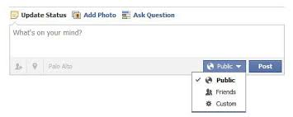
TITLE: | Verify that user enter at least one alphanumeric character.
DESCRIPTION: | Every time that user enters at least one alphanumeric character, the post button is enabled.
STEPS: | 1. - Previously, starts a session on Facebook.  2. - Go to the area of post block.  3.-Make a click on text field of the post block.  4.-Enter at least one alphanumeric character.
EXPECTED RESULTS: | Post button enabled :  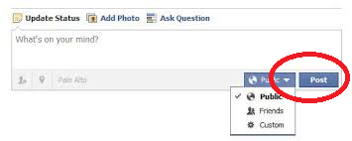  The “button post” which is marked with red on the picture.

TITLE: | Check that the default select button is public.
DESCRIPTION: | Every time that user accessed to post block, the select button is selected by default as public.
STEPS: | 1. - Previously, starts a session on Facebook.  2. - Go to the area of post block.  3.-Check that select button is selected by default as public.
EXPECTED RESULTS: | The button selected by default.  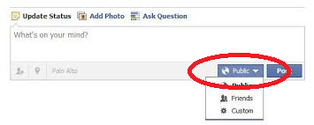  The “select button” which is marked with red on the picture.

TITLE: | Verify that select button can deploy a list with options.
DESCRIPTION: | Every time that user clicked on the select button, this deployed a list with three options: Public, Friends and Custom.
STEPS: | 1. - Previously, starts a session on Facebook.  2. - Go to the area of post block.  3.-Click on select button.  4. - Check that a list is deployed.
EXPECTED RESULTS: | Select Button displayed with three options: Public, Friends and Custom.  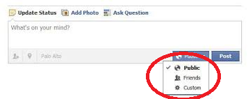

TITLE: | Verify that clicking on the post button, the entered text is published.
DESCRIPTION: | Every time that user clicks the button, the text is displayed on the wall of publications.
STEPS: | 1. - Previously, starts a session on Facebook.  2. - Go to the area of post block.  3.-Make a click on text field of the post block.  4.-Enter at least one alphanumeric character.  5.-Click on the post button.  6. - Check that the text is published on the wall of publications.
EXPECTED RESULTS: | A text posted on the block.  

TITLE: | Verify that the published texts have a recent order.
DESCRIPTION: | Every time that user posts a text on the wall, should be displayed in the order of most recent to least recent.
STEPS: | 1. - Previously, starts a session on Facebook.  2. - Go to the area of post block.  3.-Make a click on text field of the post block.  4.-Enter at least one alphanumeric character.  5.-Click on the post button.  6. Return at 2 step only one time and go to 7 step.  7. Go to the wall of publications.  8.-Verify that post is displayed in the order of most recent to least recent.
EXPECTED RESULTS: | Text published by the most recent the least recent.  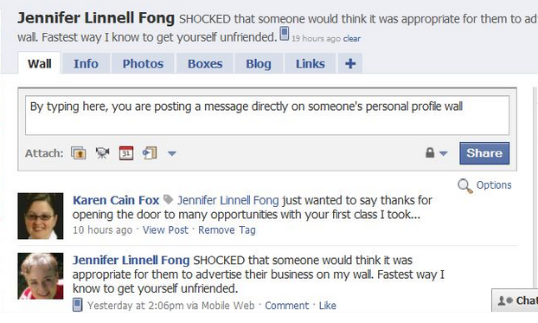

NAME: BRAYAN GABRIEL ROSAS FERNANDEZ

JHASMANY ELVIS QUIROZ OLIVERA

COURSE: QADEV04

